**CAPSTONE PROJECT**

# ONLINE MOVIE TICKET BOOKING

***Presented By:***

## 1.Bragadeeswaran N-Alagappa college of technology, Anna university-Chemical Engineering.

**OUTLINE**

◾ **Problem Statement**

◾ **Proposed System/Solution**

◾ **System Development Approach**

◾ **Algorithm & Deployment**

◾ **Result**

◾ **Conclusion**

◾ **Future Scope**

◾ **References**

# PROBLEM STATEMENT

Develop a web-based platform that allows users to easily browse, select, and book movie tickets online. The platform should provide a user-friendly interface for users to search for movies, view showtimes, select seats, and make secure payments. Additionally, the system should include features for administrators to manage movie listings, theater information, and user bookings. The goal is to create a seamless and efficient online movie ticket booking experience for both users and administrators.

# PROPOSED SOLUTION

The proposed solution for the online movie ticket booking Python project involves building a web application using Django or Flask frameworks. Users will be able to register, log in, and search for movies by title, genre, or location. Showtimes and available seats will be displayed, allowing users to select seats and proceed to payment securely. Payment integration with popular payment gateways like Stripe or PayPal will ensure smooth transactions.

Administrators will have access to a backend dashboard to manage movie listings, theaters, and user bookings. The system will incorporate features like email confirmation and ticket generation for users' convenience. Implementation of role-based authentication will ensure security, with users having different privileges based on their roles. The application will be designed with responsiveness in mind, ensuring compatibility across various devices. Finally, thorough testing and continuous improvement will be conducted to enhance user experience and system reliability.

# SYSTEM APPROACH

**Hardware Requirements:**

* Processor: Pentium 4 or more optimum performance
* Ram: Recommended 256 MB
* Hard Disk: Minimum 20 GB

**Software Requirements:**

* Operating system: windows,linux,unix,mac and other
* Programming Platform: PHP 5.0
* Database: My SQL
* Software Like: Xampp,phpMyAdmin
* Html5
* CSS3

# ALGORITHM & DEPLOYMENT

**Algorithm Design:**

* **Define the functionality:** Decide what features your system will have, such as user authentication, movie selection, seat reservation, payment processing, etc.
* **Design the data model:** Plan how you'll store information about movies, theaters, showtimes, users, bookings, etc. This could involve using databases like SQL or NoSQL.
* **Develop the booking algorithm:** Create the logic for users to search for movies, select seats, and complete bookings while ensuring concurrency control to handle simultaneous bookings.

# ALGORITHM & DEPLOYMENT

**Development:**

* **Write the code:** Implement the algorithm and functionality using Python, along with any necessary frameworks or libraries like Flask or Django for the web application, and SQLAlchemy for database interaction.
* **Develop the front-end:** Design and create the user interface using HTML, CSS, and JavaScript, or frameworks like React or Vue.js for more dynamic interfaces.
* **Implement security measures:** Incorporate user authentication and authorization mechanisms to protect user data and prevent unauthorized access.

**Testing:**

* **Perform unit tests:** Test individual components of the system to ensure they work as expected.
* **Conduct integration tests:** Test how different parts of the system interact with each other.
* **Perform system tests:** Test the system as a whole to ensure it meets the functional and nonfunctional requirements.

# ALGORITHM & DEPLOYMENT

**Deployment:**

* **Choose a hosting platform:** Select a platform to deploy your application, such as AWS, Azure, Google Cloud, or a dedicated server.
* **Set up the environment:** Configure the server environment with the necessary dependencies, such as Python, web server (e.g., Nginx), and database server (e.g., PostgreSQL).
* **Deploy the application:** Upload your code to the server and configure it to run as a web application. Ensure proper handling of static files, such as images and CSS.
* **Monitor and maintain:** Monitor the application for any issues or performance bottlenecks and apply updates or fixes as needed.

# RESULT

**FOR CUSTOMER:**

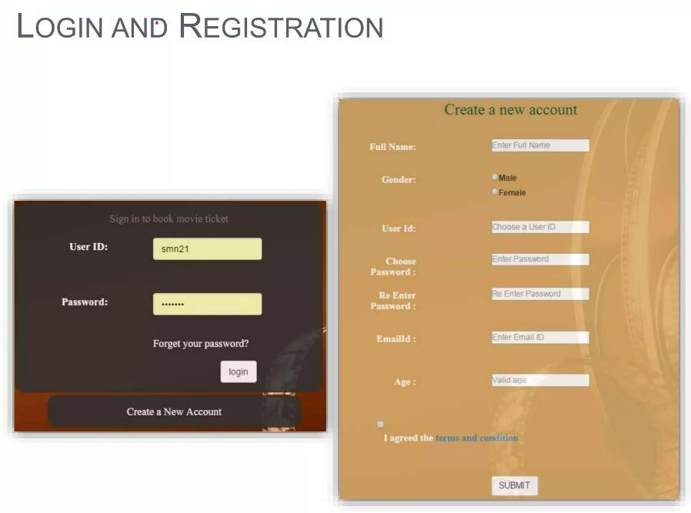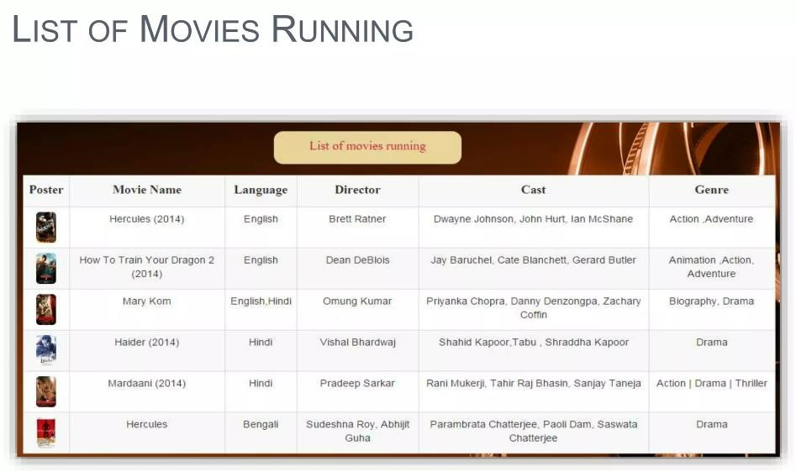

# RESULT

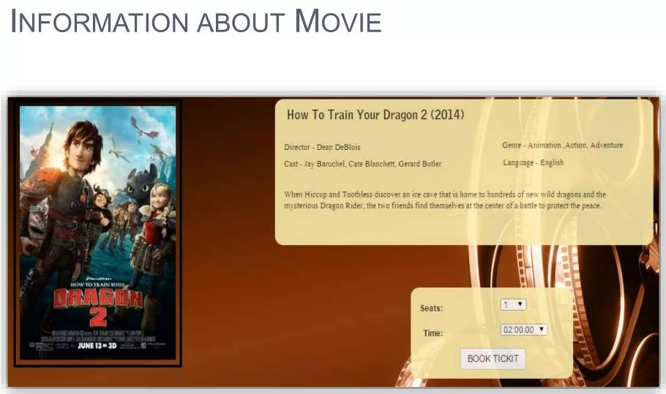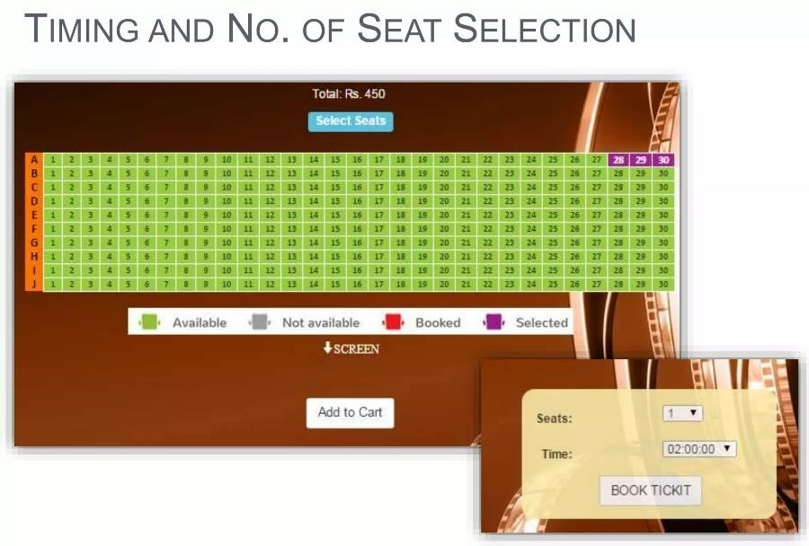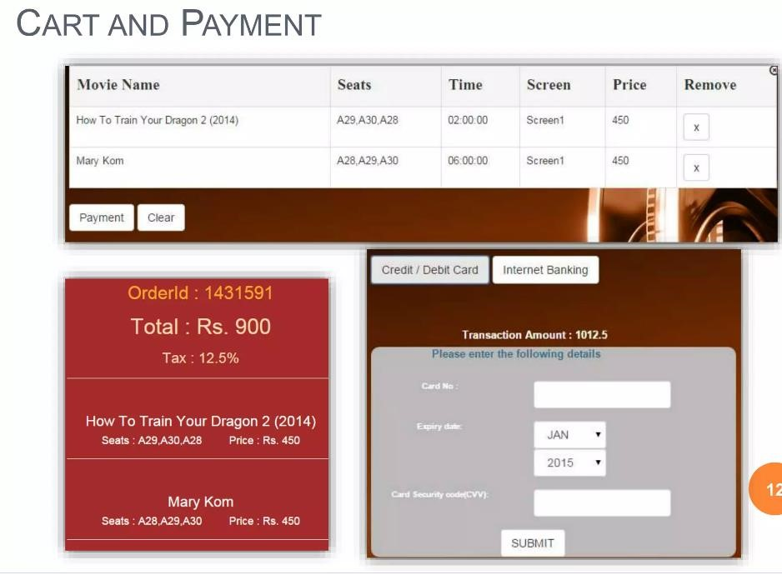

D

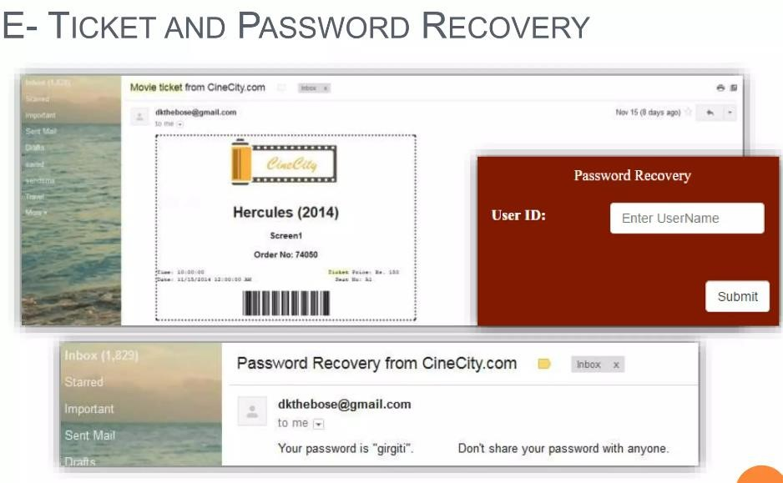

**FOR ADMIN:**

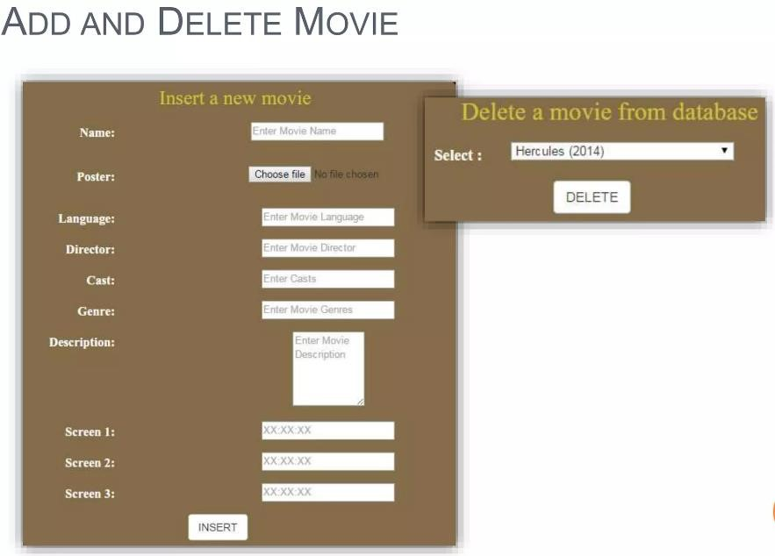

# CONCLUSION

* This project has been developed successfully and the performance of the system has been found satisfactory
* Use of this interface helps customer in having immediate information about running movies and reserve their seat without wasting their precious time
* User friendly Interface also for the admin to add and delete movie information.

## FUTURE SCOPE

➢More features can be added like

* Allow customers to comment on movies
* Provide a list of upcoming movies
* SMS notification after successful seat reservation.

➢Encrypted Webpage to ensure customer privacy and transaction security.

➢More user friendly interface also in small screen devices.

# REFERENCES

* [www.w3schools.com](http://www.w3schools.com/)
* [www.google.com](http://www.google.com/)
* [www.tutorialspoint.com](http://www.tutorialspoint.com/)
* [www.Phpmanual.net](http://www.phpmanual.net/)

**THANK YOU**